Practical 5 :

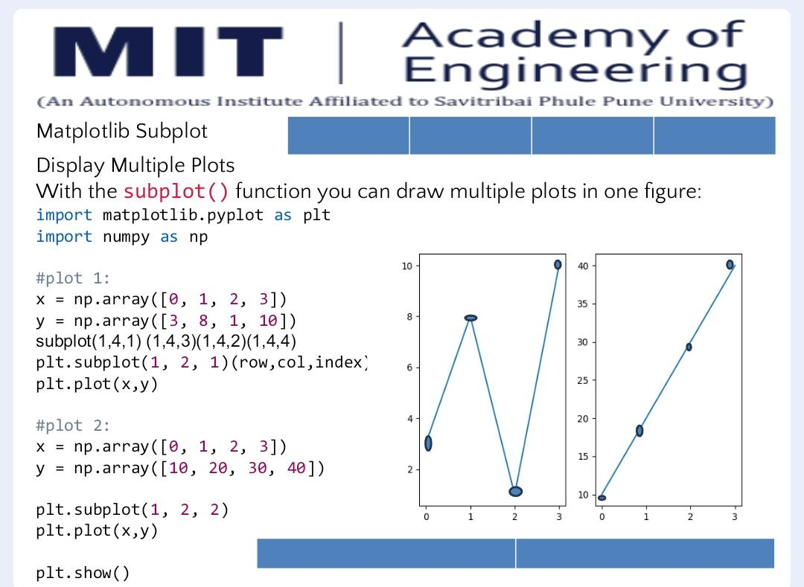

Code :
import matplotlib.pyplot as plt
import numpy as np

# plot 1:
x = np.array([0, 1, 2, 3])
y = np.array([3, 8, 1, 10])

# The syntax is plt.subplot(nrows, ncols, index)
plt.subplot(1, 2, 1)
plt.plot(x, y)

# plot 2:
x = np.array([0, 1, 2, 3])
y = np.array([10, 20, 30, 40])

plt.subplot(1, 2, 2)
plt.plot(x, y)
plt.show()

Output :
